Advanced Engineering Mathematics, by Erwin Kreyszig 10th. Ed.

**Problem Set 6.6**

No. 1



No. 2





ℒ

ℒ ℒ

No. 3

ℒ

ℒ ℒ

另解

ℒ

ℒ ℒ

No. 4

ℒ

ℒ



Or









And



















Note: s + k > 0

In this problem



No. 5



ℒ

ℒ ℒ



No. 6



ℒ

ℒ

ℒ





No. 7

 

ℒ

ℒ

ℒ



另解

ℒ





  





No. 8

ℒℒ

Or

  

No. 9



ℒ

ℒ ℒ



ℒ ℒ













ℒ

No. 10



ℒ

ℒ ℒ

ℒ ℒ

No. 11



ℒ

No. 12



No.13

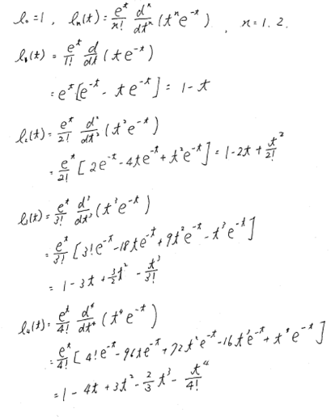

No. 14

 

ℒ -1 ℒ -1

Or

ℒ-1 



No.15





and 

ℒ -1

ℒ -1

Or 



ℒ -1

And ℒ -1

ℒ -1









No.16

 

And ℒ-1ℒ-1

ℒ-1 

No.17



Set ℒ -1 then, ℒ -1;

ℒ -1ℒ-1



No.18



Set ℒ -1 then, ℒ -1;

ℒ -1ℒ-1ℒ-1



No.19



If ℒ-1, then ℒ-1



ℒ-1



No.20



Set ℒ -1then, ℒ -1;

ℒ -1ℒ-1

